Project Tau Summer Design Competition 2020

Christopher Evagora ‘23

This summer I have been designing my own 6 degree of freedom spherical robot arm I named Terry. Robot arms with 6 dof are very popular in modern factories that require high precision and repeatability such as in car manufacturing plants, though they are also extremely popular in robotics as they are a great platform to maneuver and manipulate objects in 3d space. This project seemed like a great idea to pursue because it could enable me to do robotics projects in the future that require such a setup, and because 6 dof robot arms are the coolest. My plan is not only to design, but to build, wire, and code the robot from scratch. Something unique about my design might be the ball screws that drive j2 and j3 with push rods instead of connecting the output of a motor shaft to the axis of rotation. I did this to remove as much backlash in j2 and j3 without the need for super expensive harmonic / cycloidal gearboxes that are standard in most industrial robot arms. I also implemented a differential in j5 and j6 to allow j6 to rotate continuously.

Here is a picture of Terry from solidworks along with the underlying skeleton sketch I will base the kinematic model on:

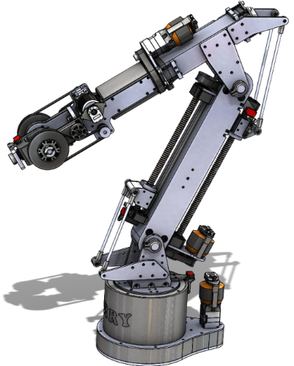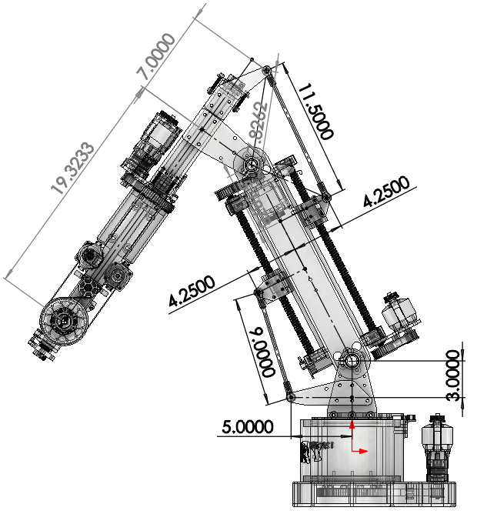

At their core, robot geometries are simply a series of mechanical joints that rotate. To deconstruct a robot’s underlying kinematic model, a standard set forth by Denavit and Hartenberg called DH parameters can be used to describe the joint transformations from one joint to the next. Because the robot is spherical, loosely meaning that joints 4,5, and 6 act on a single point, I plan to derive an analytical solution to the inverse kinematic model. A kinematic model that applies to Terry and follows the DH convention is as follows: 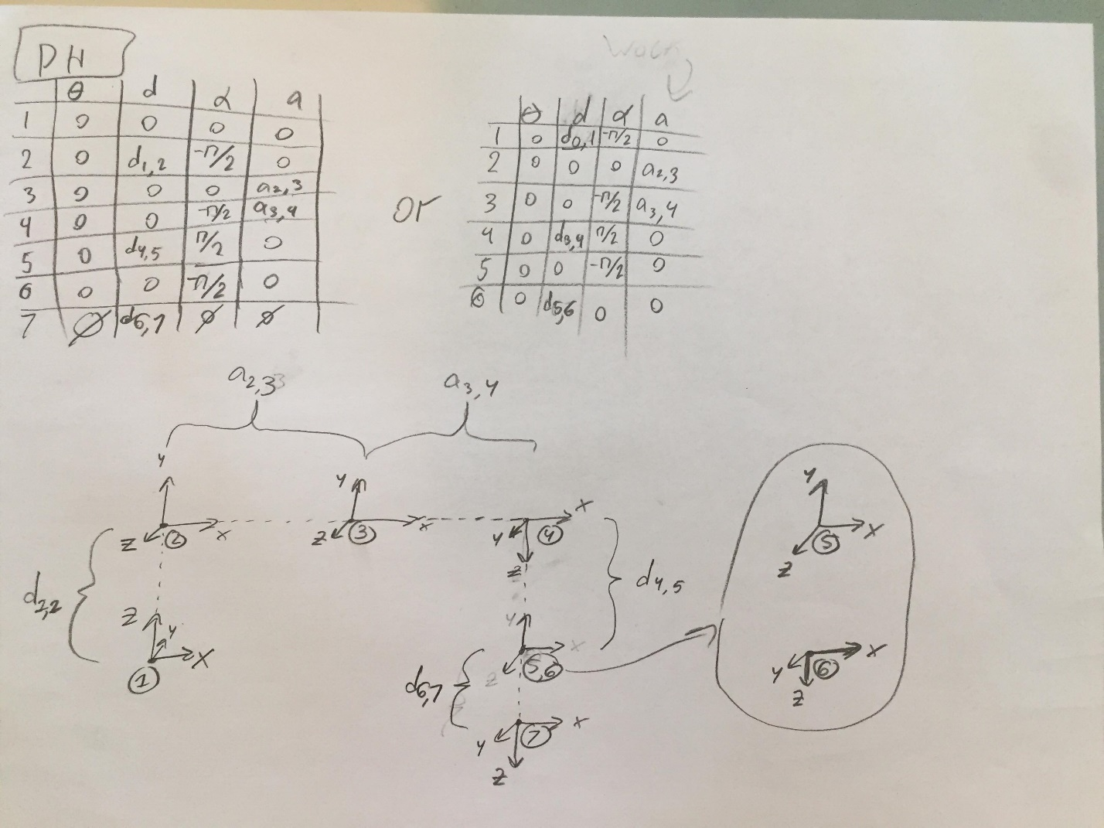

All of this math plus other stuff I did not write about or document will be extremely necessary when it is implemented, though I have eaten up nearly all of the summer with the design and assembly of Terry. This short description is by no means complete, and more progress will surely be made in the coming months following the end of this summer, so make sure to watch for activity on my github page where all of this will be uploaded. A secondary repository called TBrain is where the code for the robot will be maintained.

>>> <https://github.com/evagorac/Terry> <<<